**Online Test Application ScreenShot :-**

Quiz Section –

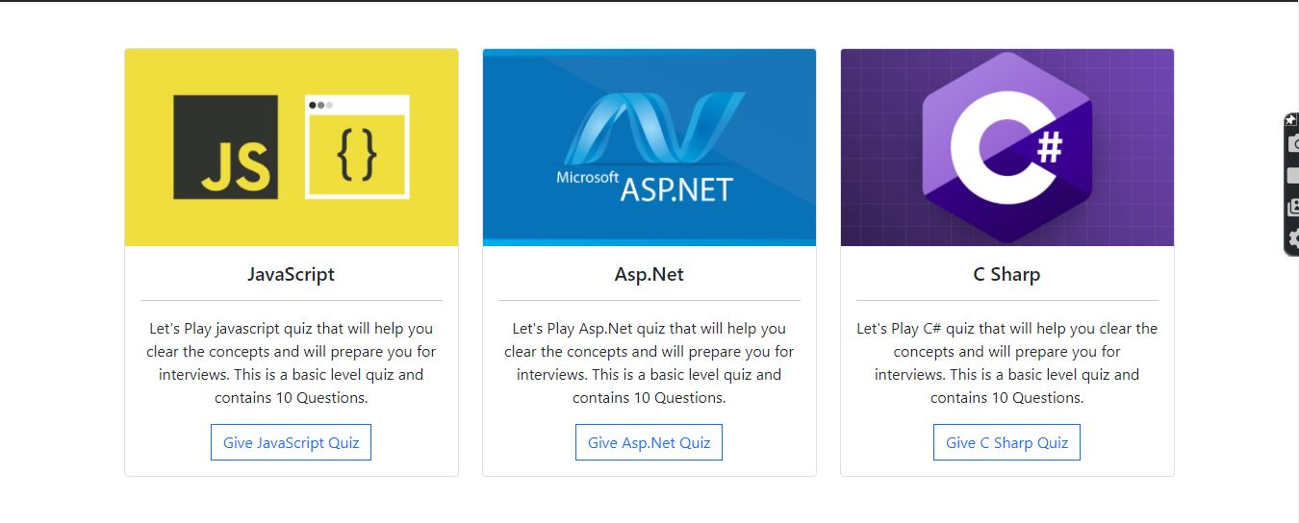

Navbar Section –



Quiz-Opening Section –

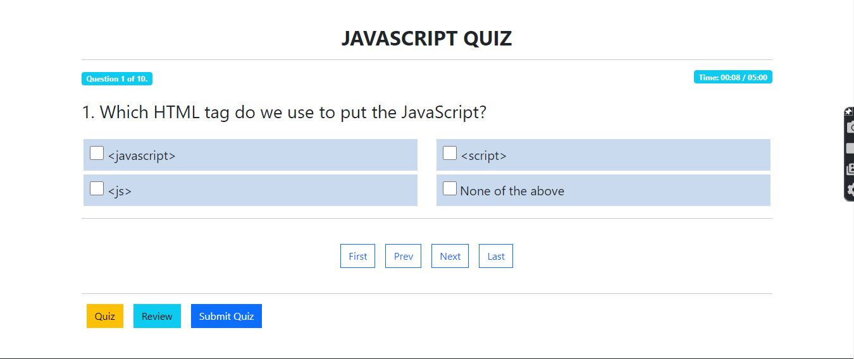

Result Section –

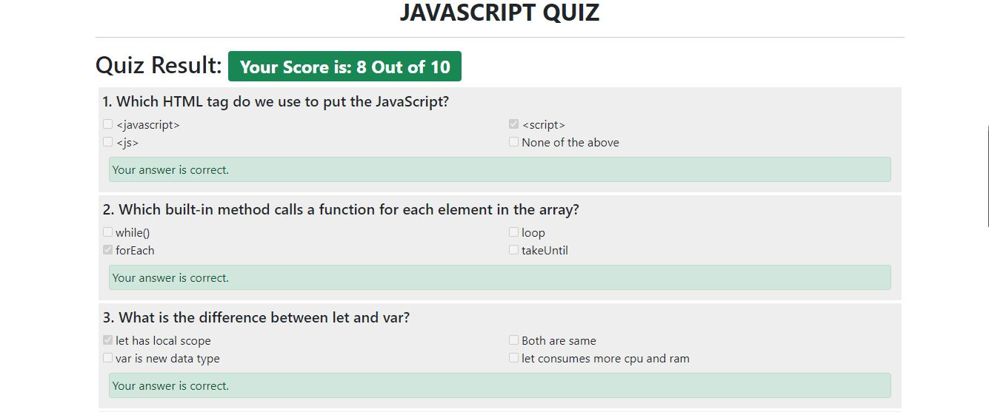

Footer Section –

